**VIDEO GAME ANALYSIS**

**INTRODUCTION :**

Concise primer provides instruction on the basic building blocks of game analysis— Game analysis allows us to understand games better, providing insight into the player–game relationship, the construction of the game, and its social cultural relevance. As the field of game studies grows, videogame writing is evolving from the mere evaluation of game play, graphics, sound, and replay ability to more reflective writing that manages to convey the complexity of a game and the way it is played in a cultural context. Introduction to Game Analysis serves as an accessible guide to analyzing games using strategies borrowed from textual analysis. Clara Fernández Vara’s examination of context, content and reception, and formal qualities as well as the vocabulary necessary for talking about video games’ distinguishing characteristics. Examples are drawn from a range of games, both digital and non-digital—from Bio shock and World of War craft to Monopoly—and the book provides a variety of exercises and sample analyses, as well as a comprehensive glossary and graphy. Clara Fernández-Vara is Associate Arts Professor at the Game Center, New York University. She teaches courses on videogame theory and game narrative, and works as a freelance game designer and writer. As a researcher, her main interest is in exploring the integration of stories and gameplay, as well as developing theoretical frameworks to understand games better.

**PURPOSE :**

The goal of a game analysis is not to establish how good or bad a game is, but highlight and rationalize the aspects that make the game worth studying and contribute to understanding videogames better.

**EMPATHYMAP: *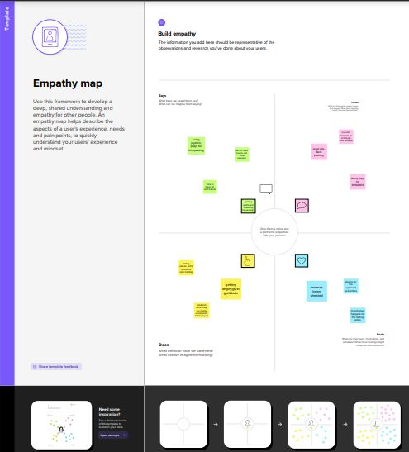***

**BRAINSTORM:**

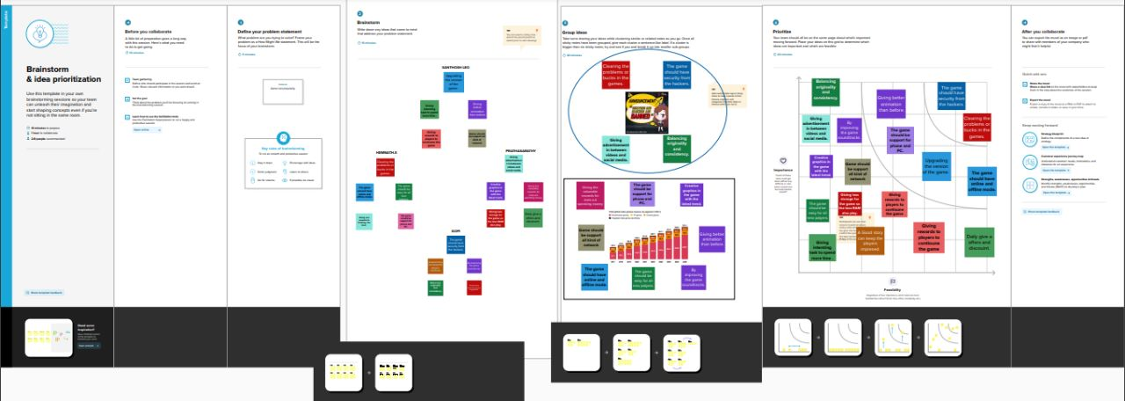

**RESULT:**

**DASHBOARD:*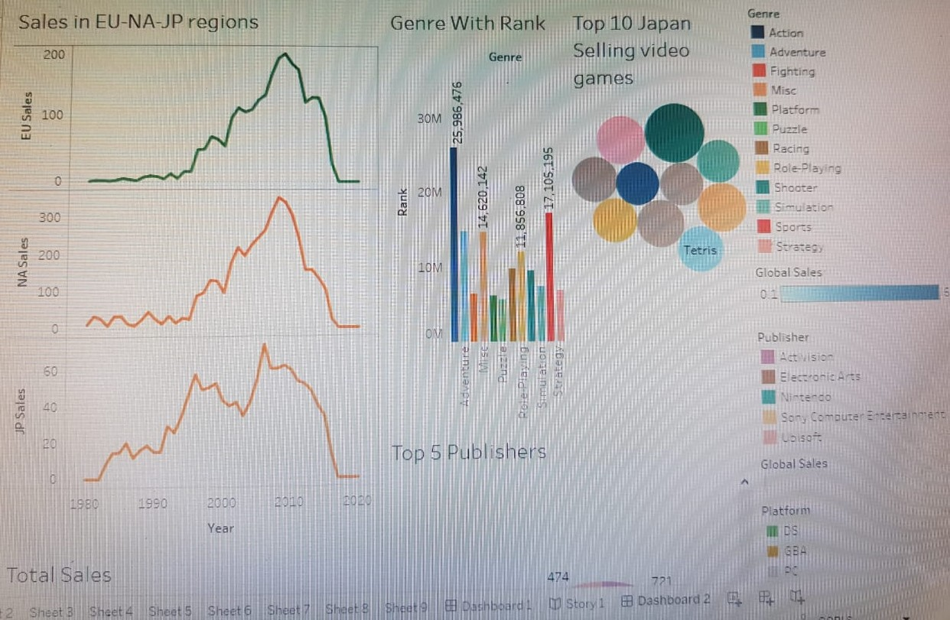***

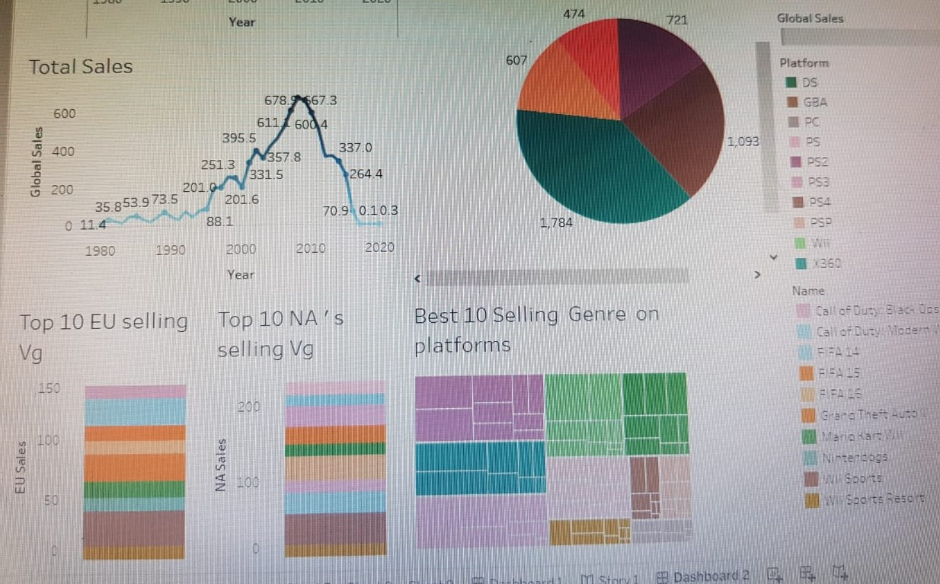

**STORY:**

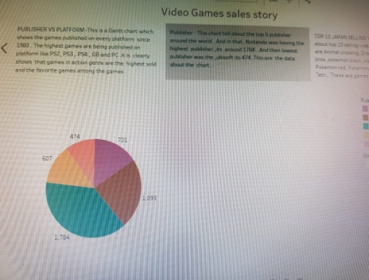 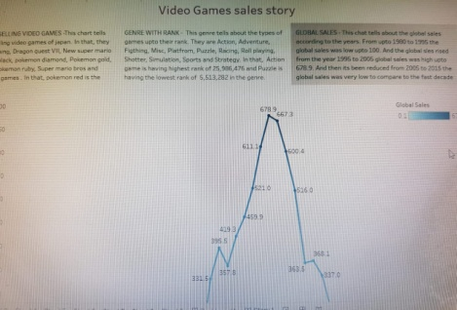

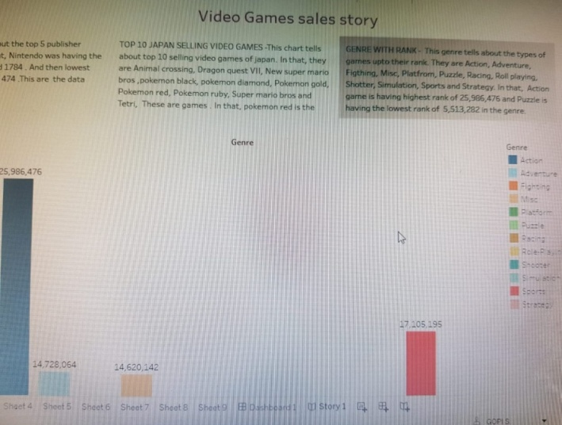

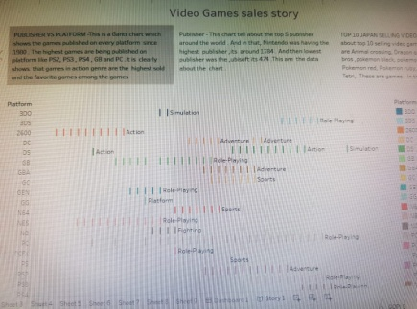

**ADVANTAGES:**

* They speed up response times.
* They encourage teamwork.
* They stimulate creativity, focus and visual memory.
* They improve strategy and leadership.
* They teach languages.
* Critical thinking.

**DISADVANTAGES:**

* Behaviour and mental changes.
* Lack of other hobbies and poor academic performance.
* Lethargic nature, which will also lead to weight gain.
* Gaming addiction can slow down the brain growth.
* Gaming addiction negatively affects eyesight and also results in Insomnia.

**APPLICATION:**

Gaming Applications means all applications, supporting documents and supplemental information required by any Gaming Authority or required pursuant to any applicable Gaming Law necessary to effectuate the provisions set forth in any of the Transaction Documents or any of the rights, remedies or obligations there under.

**CONCLUSION:**

Video games are a form of media that is often associated with negative health consequences. However, when games are played in moderation and with mindfulness, they are a viable source of stress relief as well as a catalyst for mental health improvement and development of social skills. Video games themselves are a relatively modern form of entertainment. They are engaging and immersive on a level different from that of traditional board games and other forms of entertainment. The player actively contributes to the level of satisfaction he/she attains from this medium and thus is more invested and willing to engage in the elements of the video game. The amount of play time is also an important factor in the effects of gaming. Although excessive playtime can have negative consequence, gaming in moderation can be healthy, fun, and educational.

**FUTURE SCOPE:**

The future of the video game industry looks dazzling. Consumer demand is growing, technology is advancing quickly, and new monetization models are taking off. Bain’s analysis forecasts that global revenue for games could grow by more than 50% over the next five year. And gamers’ foothold in virtual worlds—collectively called the meta verse—is far ahead of other consumers.

All this suggests that gaming will take consumers’ time from other forms of media and be the foundational platform for both other media and non-media experiences, becoming an ever greater part of our daily lives.

**SOURCE CODE;**

**https://drive.google.com/file/d/1rStOxB0ZRX3q-005m873yhiksyLj9xcR/view?usp=share_link**